Video transmitter BEASTFPV 4.9-5.8GHz 64CH 2.5W VTX
- Functional diagram
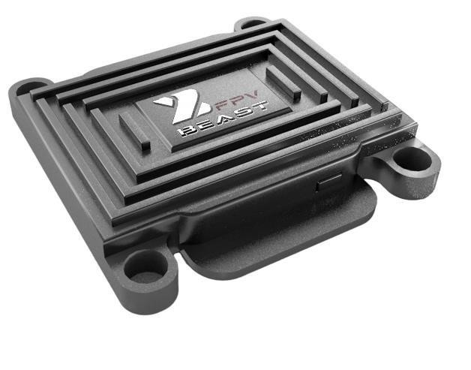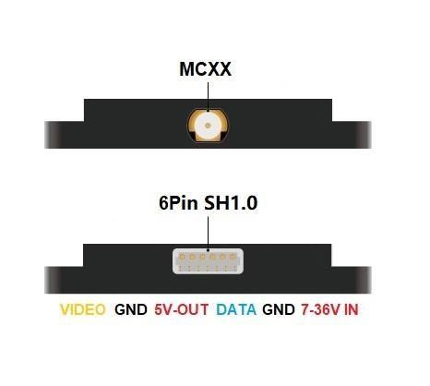
port | definition |  | interface | definition
7-36V IN | Input voltage 7-36V |  | DATA | VTX Video Transmitter Control Input (IRC Tramp)
5V-OUT | Output voltage 5V |  | VIDEO | Video signal input
GND | Ground wire (Minus) |  | GND | Ground wire (Minus)

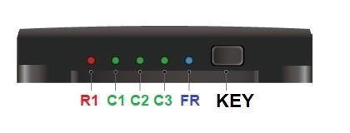
- Display
Description of LEDs: (image on the right)
- Power indication: red lightR1, the number of flashes corresponds to the power. (1 blink – 25mW,
2 blinks – 400mW etc... see description below “Video transmitter power indicator”)

- Display of a group (range) of frequencies (frequency grid): blue lightFR, the number of flashes corresponds to the current frequency grid. (1 blink – the range of the A channel grid (FR1), 2 blinks – the range of the B channel grid (FR2), etc. (see the description below “Frequency Table” FR)

- Display of frequency channels: green indicatorsC1/C2/C3, the operating state of the three indicators corresponds to the current frequency (channel). (LEDs are not in a row - channel 1, only the first green LED is lit - channel 2, etc. (see the description below “Frequency Table” CH C1 C2 C3)

3. Video transmitter power indicator:
RF POWER LED | 25mW | 400mW | 800mW | 1500mW | 2500mW | Fault
R1 | 1time | 2time | 3time | 4time | 5time

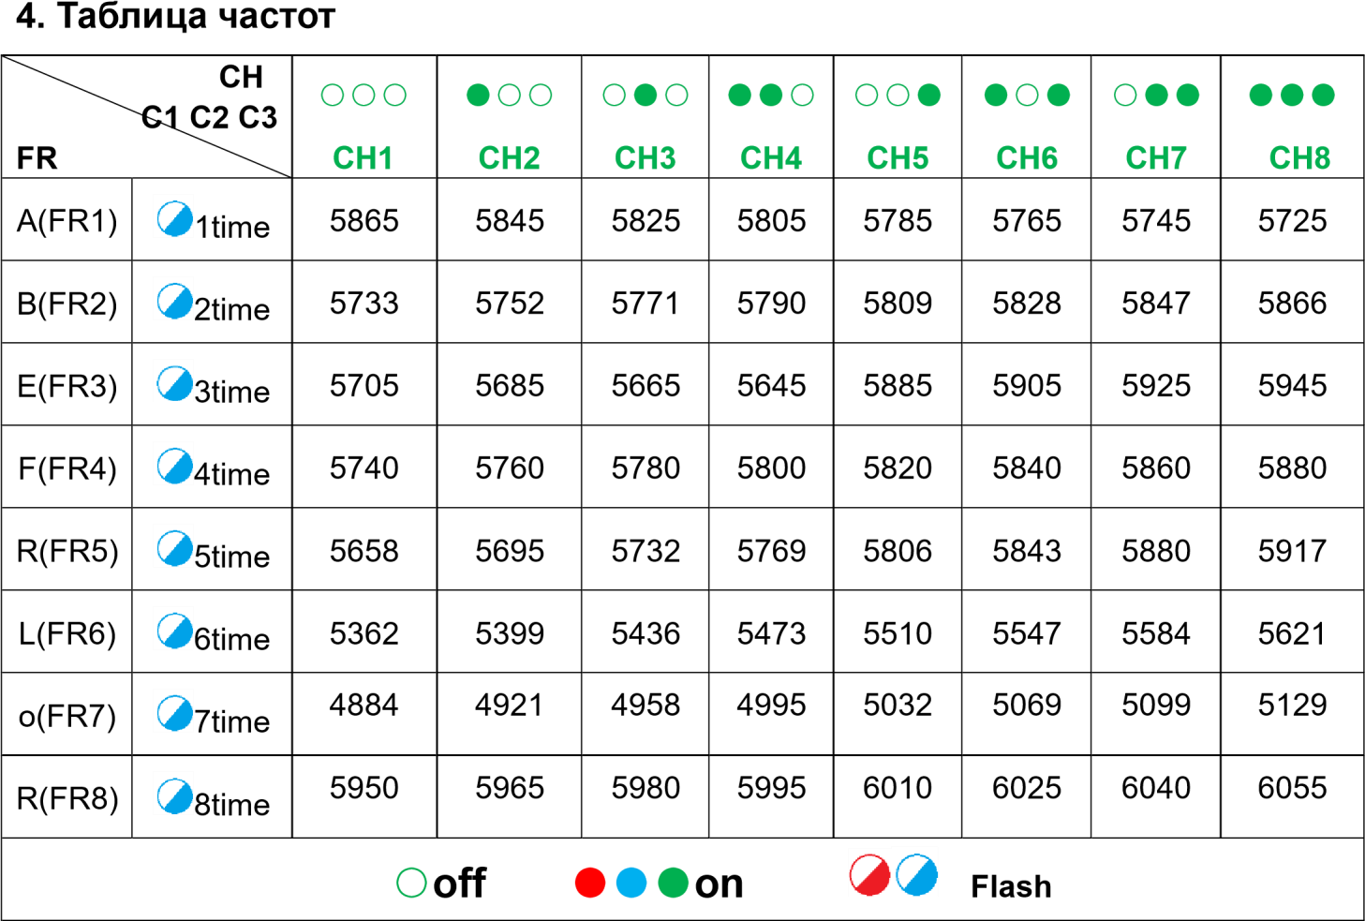

5. Setting up the video transmitter in manual mode

IRC function (setting via BetaFlight) only supports channels 1-40CH, because of this, the 4.9GHz frequency group (L(FR6), O(FR7), R(FR8) can only be set up using the button in manual mode.

To configure the video transmitter in manual mode, to enable low frequencies 4.9Ghz. It is important to disable the IRC function in the BetaFlight settings "ports", if it was previously enabled (how to do this, see the screenshot below).
Otherwise, if this is not done, it will not be possible to configure the video transmitter manually.

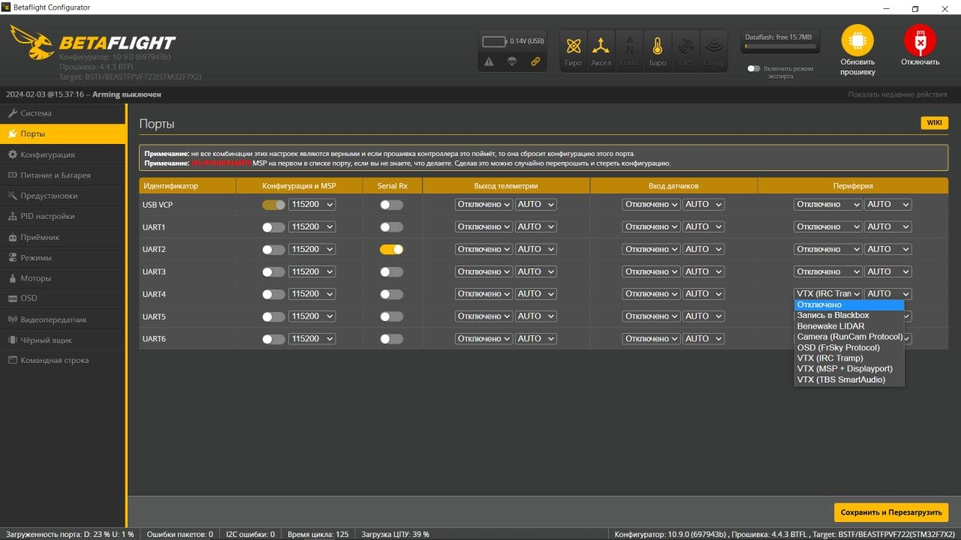

After the IRC function has been disabled, the video transmitter must be unlocked (Initially, when leaving the factory, the video transmitter is locked and manual configuration is not available).

When the R1 indicator is always red, you need to press and hold the button for 15 seconds to unlock the frequency and power.
1) Unlocked state: R1 indicator flashes. 2) Locked state: R1 indicator always lights.

Power adjustment:
This video transmitter has 5 power levels: 25/400/800/1500/2500 mW. To adjust the power, press and hold the button for 6 seconds, after which the video transmitter will go into the power adjustment mode. The power is selected in order by pressing the button once. The number of flashes (blinks) of the red indicator R1 will correspond to the selected power: 1 blink - 25 mW, 2 blinks - 400 mW, etc. (pay attention to: “3. Video transmitter power indicator”). To save the selected power, you must wait 5 seconds, after selecting the power - the video transmitter will save the value. (When adjusting the power of the video transmitter - the red power indicator R1 blinks, and the other indicators go out).

Adjusting frequency and channel selection:

Switching frequency group (range grid):To set up the range grid, you need to press the button and hold it for 2 seconds. The video transmitter will go into the range grid setting mode, pressing the button once helps to select the range in order. The number of flashes (blinks) of the blue FR indicator corresponds to the selection of the range grid: 1 blink - range grid A (FR1), 2 blinks - range grid B (FR2), etc. (pay attention to: “4.Frequency table” FR). To save the selected range grid, you need to wait 5 seconds, the range grid will be saved. (When selecting a range grid - the blue FR indicator blinks, and the other indicators go out).

Switching channels:To switch video transmitter channels, you need to press the button once and select the channel you need. Green indicators (LEDs) C1 C2 C3 are responsible for displaying channels. Green LEDs are off – channel 1, the first green LED is on – channel 2, etc. (pay attention to: “4.Frequency table” CH C1/C2/C3). To save the selected channel, you need to wait 5 seconds, the channel will be saved.

PIT setting/PIT mode： 1) Double click the video transmitter button and the red power indicator R1 will go out (double click again to exit PIT mode) 2) Enable PIT function in OSD menu.

Recommendation for choosing frequency range and channel:
To select the frequency 4.9Ghz: you need to transfer the video transmitter to the frequency grid O(FR7) (the blue indicator (LED) should blink 7 times). Then select channel 2 (the first green indicator is on). This frequency range is the most optimal, and corresponds to the frequency: 4921 It is not recommended to use a lower frequency 4884 or the frequency grid R(FR8), since the standard antenna is not designed for this frequency range.

6. Setting up a video transmitter using BetaFlight.

To configure the video transmitter using the BetaFlight program, you need to solder the DATA signal wire to a free UART port on the flight controller (TX port) - this is necessary to configure the video transmitter.
After that, go to the BetaFlight program, and go to the “ports” section, in the last “peripherals” tab, you need to select “VTX (IRC Tramp)” in the corresponding UART port. (See the screenshot below. (The screenshot shows an example of UART port number 4. The DATA wire was soldered to the TX4 port on the flight controller, and UART4 was selected in the “ports” section).
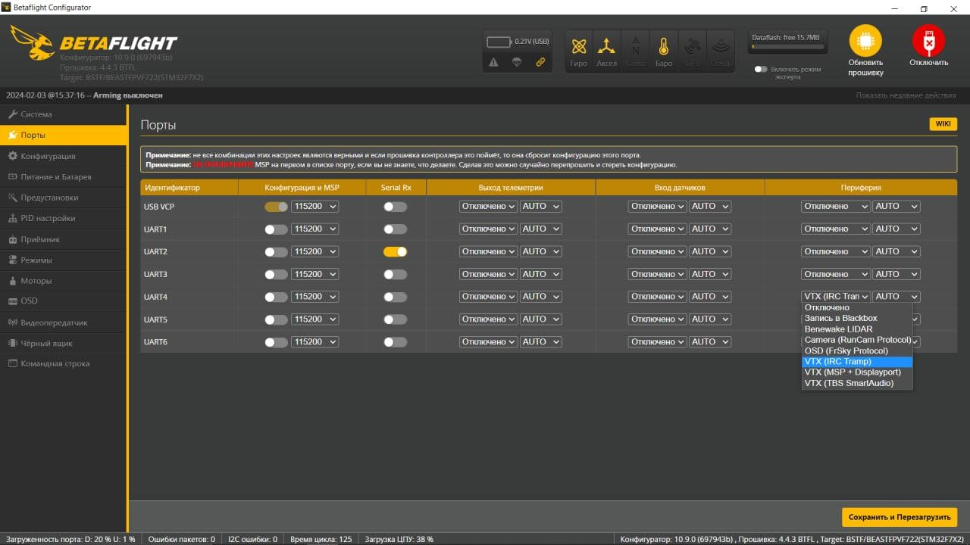
After selecting the settings, you must click: “Save and Restart” to apply the settings.
Next, you need to go to the “Video transmitter” section and add the VTX table (the VTX table is on the website in the “Instructions” section) “Load from file” and select a file with the .JSON extension. After that, you can select the frequency range grid you need, select the desired channel and power. Finally, you need to click “Save” to apply the settings.

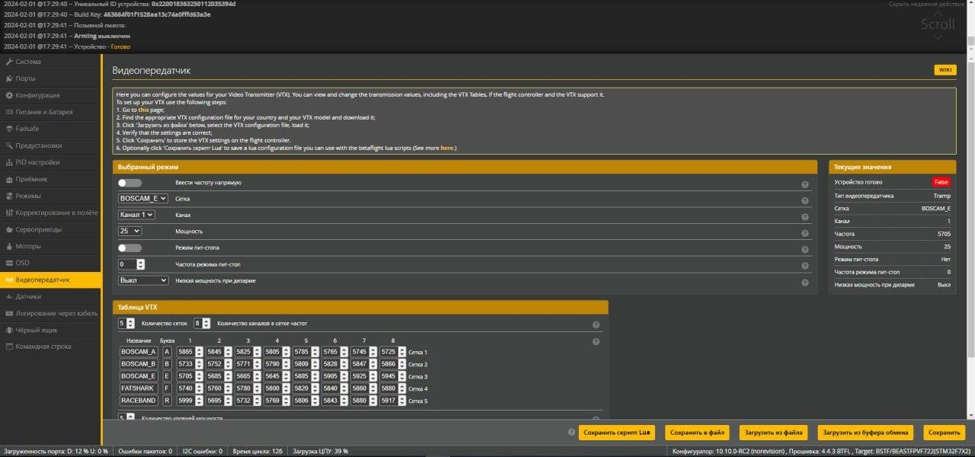
IRC function (configuration via BetaFlight) supports channels 1-40CH only. Low frequencies must be configured manually.

7. Video transmitter parameters

Working voltage | 7-36V
Current consumption | ≤450mA@12V, 800mW  ≤850mA@12V, 2500mW
Output power | PIT/25mW/400mW/800mW/1500mW/2500mW
Frequency range | 4.9GHz – 5.8GHz
Number of channels | 64CH
Antenna connector | MMCCX
Video format | NTSC/PAL
Video transmitter protocol | VTX (IRC Tramp)
Completeness | VTX BeastFPV 4.9-5.8GHz 64CH x 1  4.8-6GHz 3DBi RHCP Antenna x 1  6Pin SH1.0 Wire x1

